

Release notes--McNav-1.1.1.20250624-Release

Content

1. Version information 1

2. Newly added features 1

3. Fixed issues 14

4. Precautions 15

**June 24, 2025**

**McNav-1.1.1.20250621-Release**

# Version information

Version name:McNav-1.1.1.20250624-Release-2454802.apk

Release date: June 24, 2025

Version number:McNav-1.1.1.20250624-Release

Version Type: Official version

# Newly added features

1. Added TX73 Basic registration code, in the case of lack of 3D registration code, the data of the drawing type cannot be selected in the import interface, and the imported drawings are not displayed in the design list and view, nor can they be operated in the master control panel
2. Remove the [new plane] function in Design interface
3. Added the [On-site Design] button in the shortcut function drawer, if the calibration is not completed, the prompt: "Please finish the calibration first!". If the calibration has been completed, the panel will pop up for the user to select the type of data they wish to create, which consists of four categories in two categories:

3.1 Slope: single-point slope determination, two-point slope determination (both slope type data)

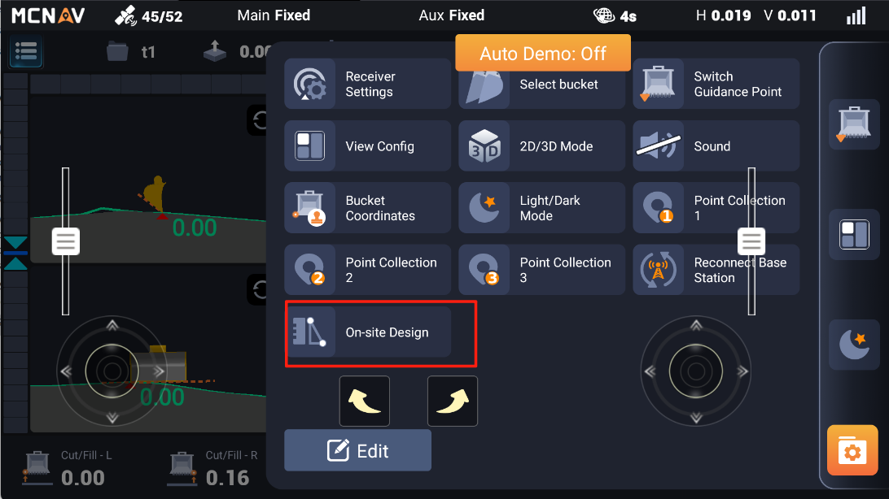

A.one point slope:

1. Confirm a point in four ways
2. Choose from the map by single click the point which is collected before

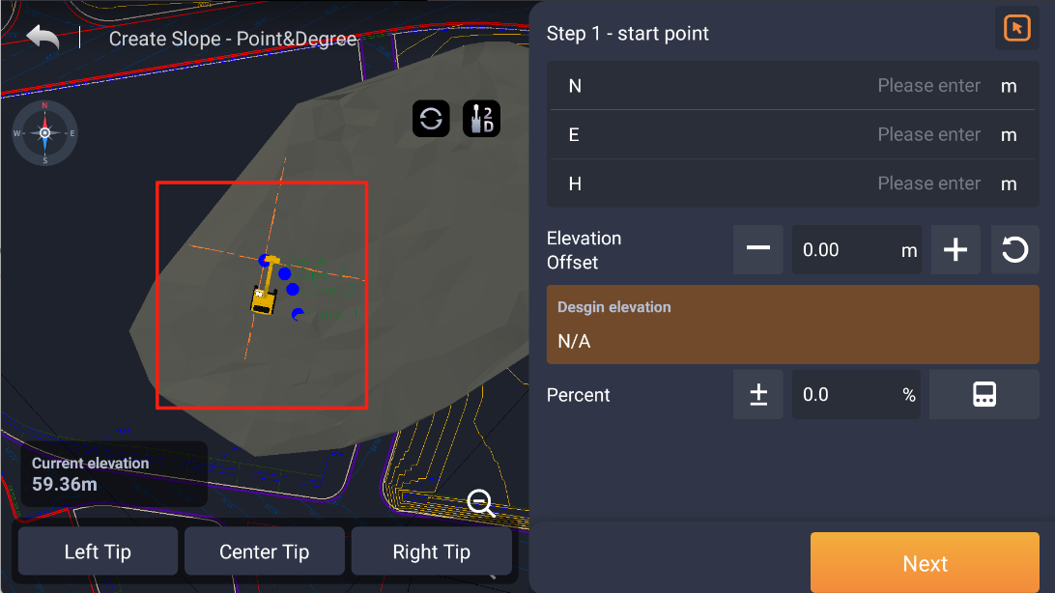

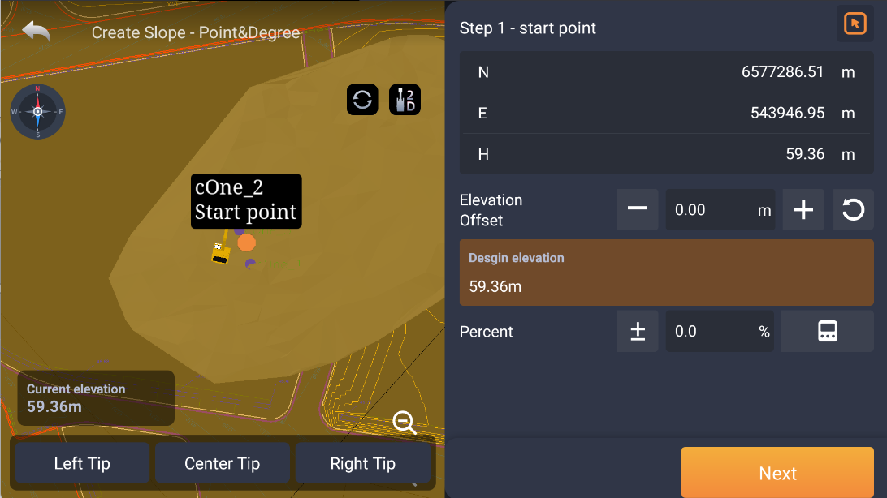

Note:Make sure that the points you need have been collected and are on the map, if not, use the [Point Collection] in the quick drawer.

1. Choose from the list

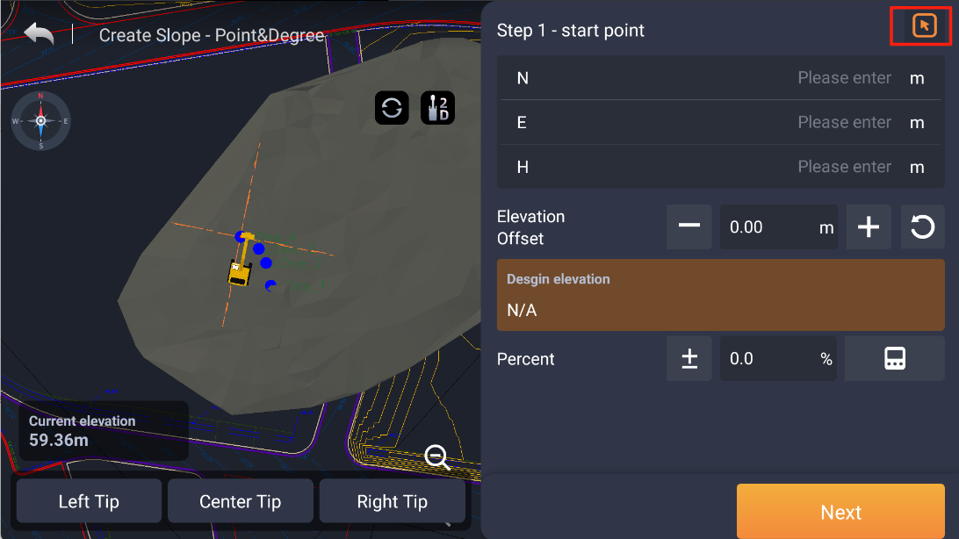

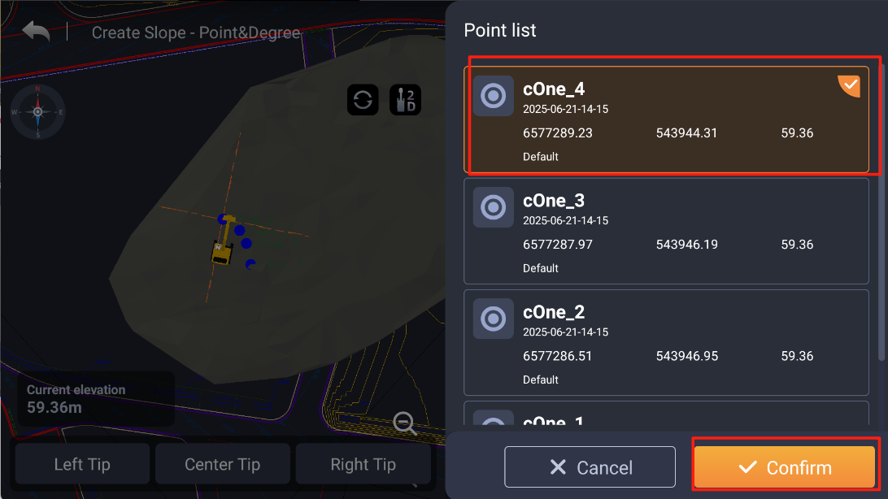

1. Collect based on the actual location where the bucket tip is located

Noted:The collection point creates a temporary point that disappears after being collected again or exited

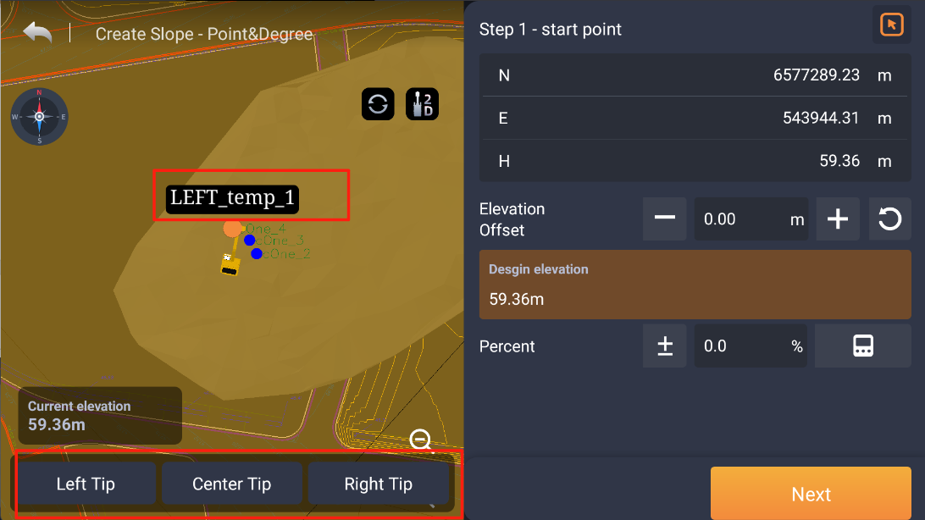

1. Input the N E H

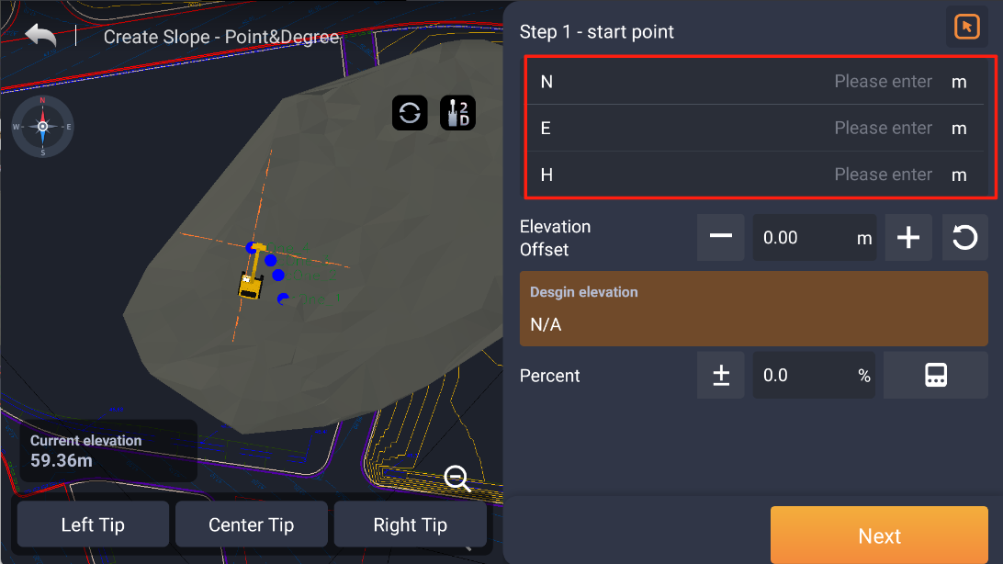

1. Enter an elevation offset to raise or lower the elevation of the point

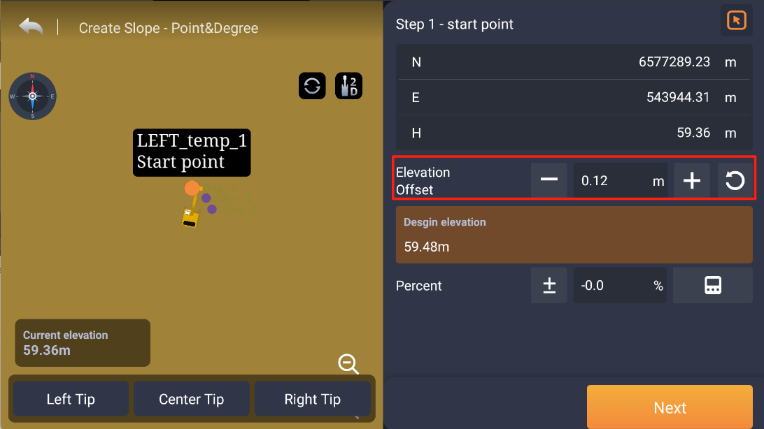

There is a quick button to clear offset 

The actual elevation after the offset (the current elevation offset value) is also displayed and is not editable

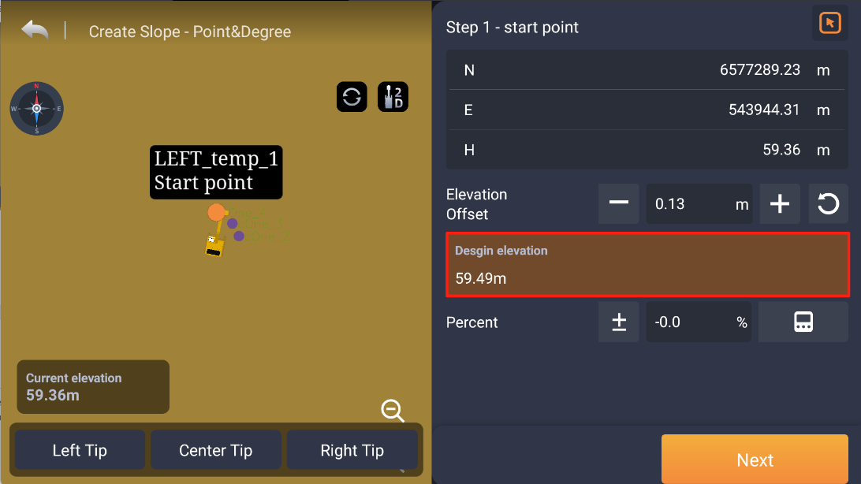

1. Enter the percentage information of the slope,support quick negation

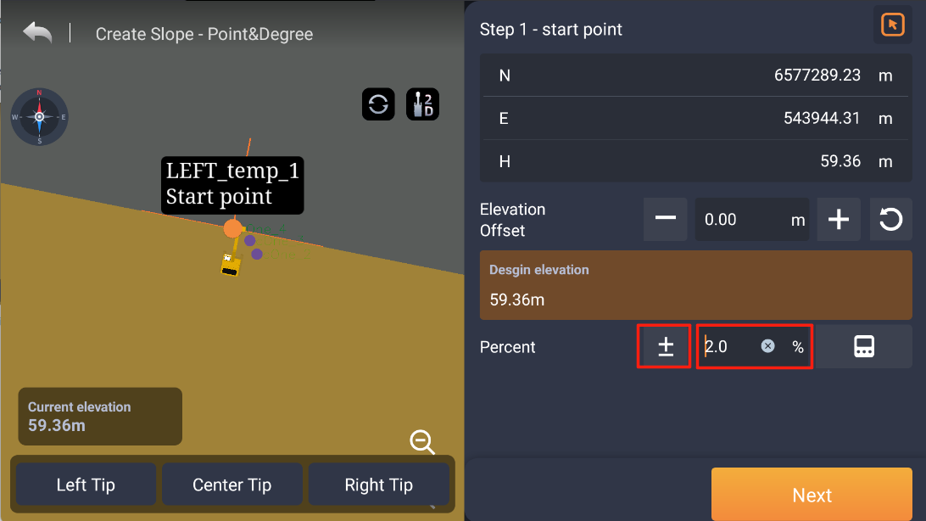

If you don't know the percentage of the slope, you can click on the computer icon to convert the parameters

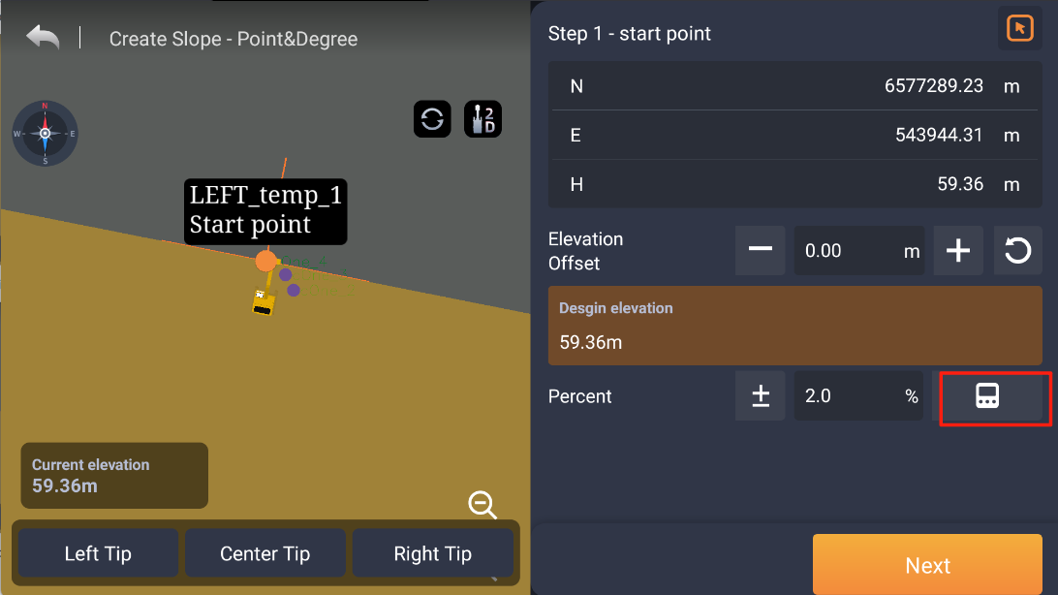

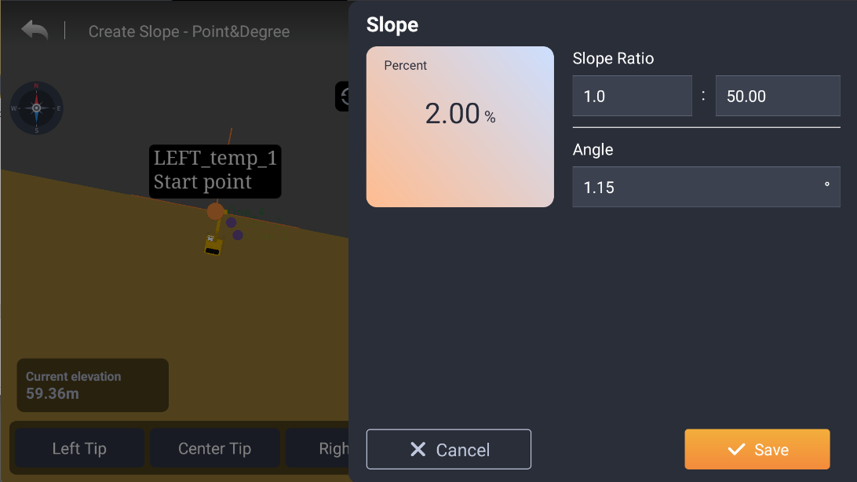

1. Click Next to edit the slope name and layer

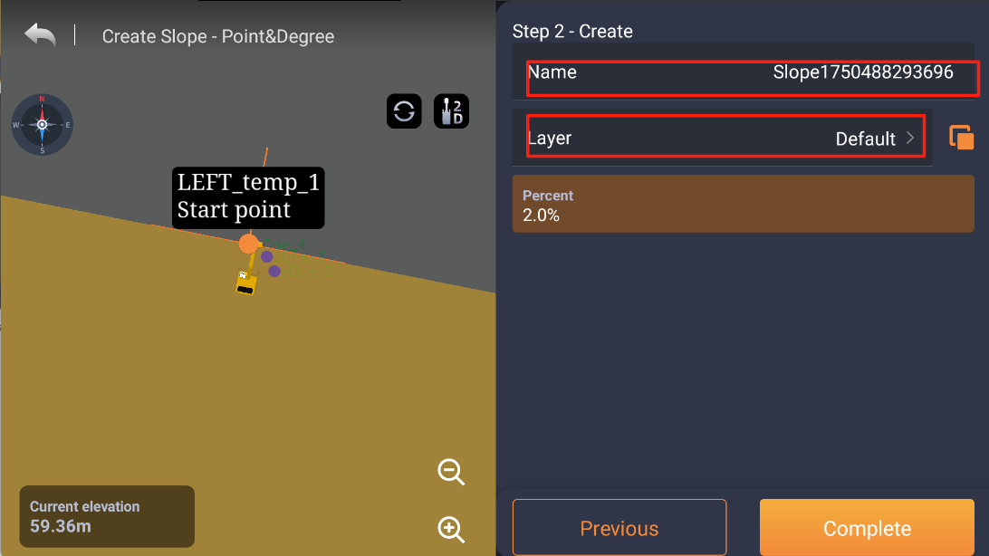

1. Click the quick button for design data to find and apply it

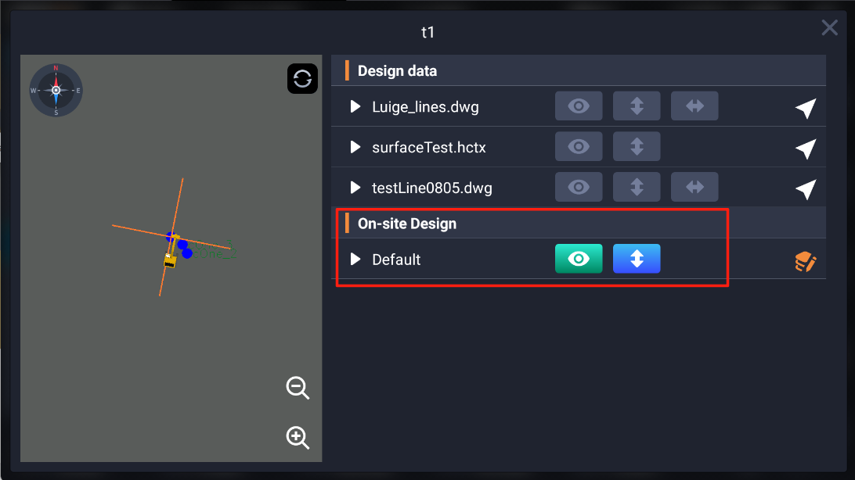

B：Two points slope

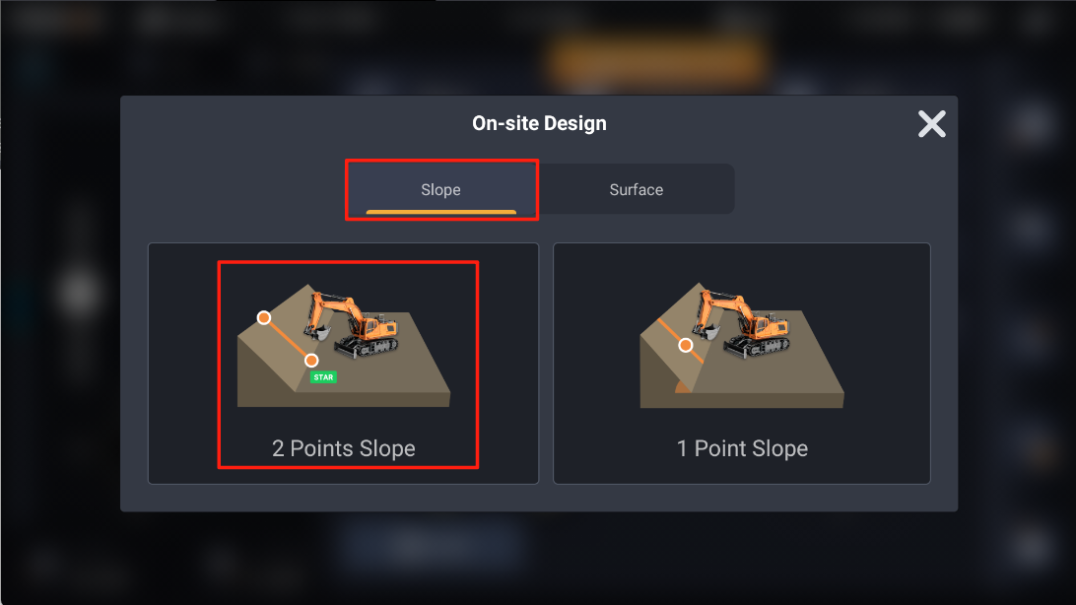

1. There are four ways to capture a start point

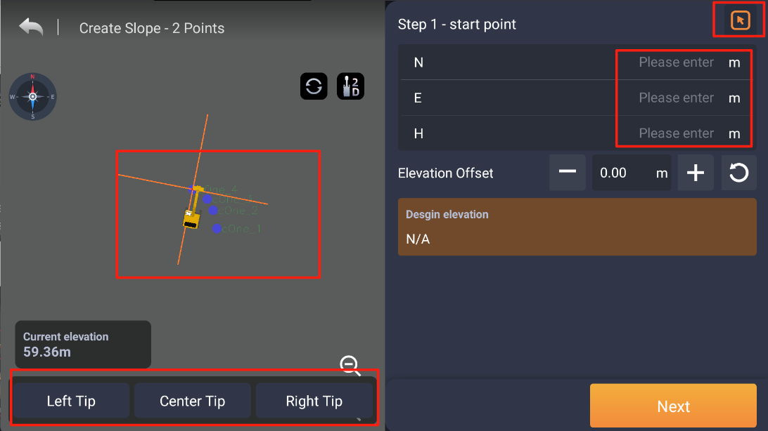

1. Collect end point in the same way,then enter the slope information, including the offset value(for end point) and the slope information

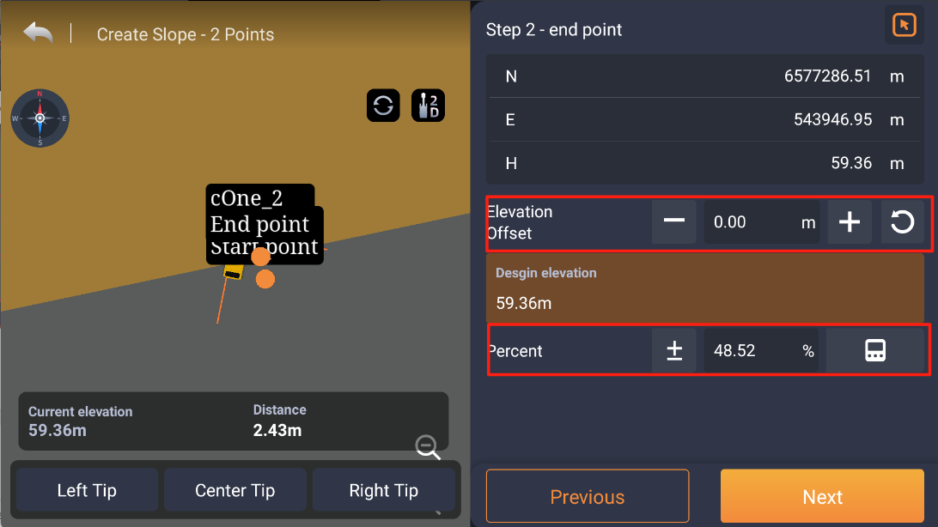

1. Find and apply it by clicking on the shortcut button of the design



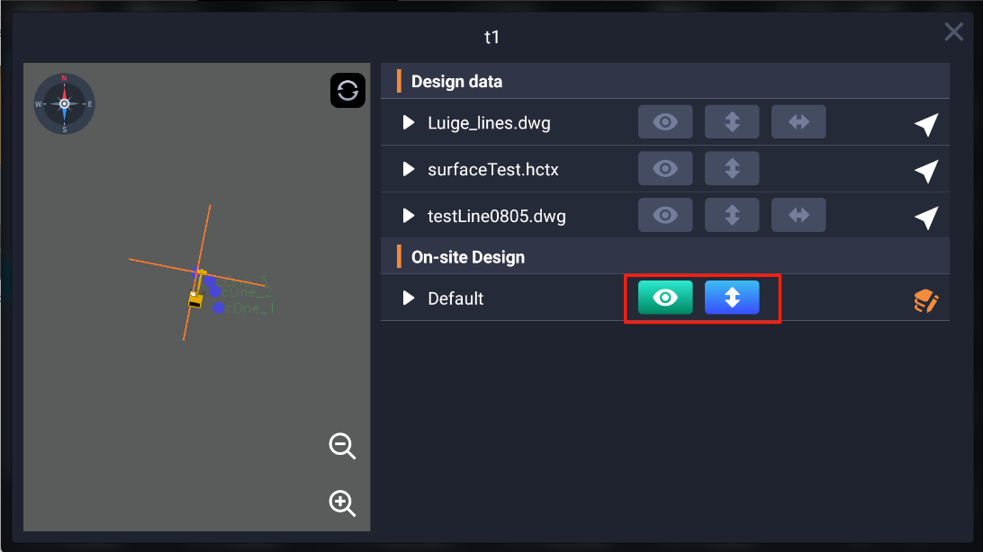

3.2 Surface: Flat Plane,Foundation

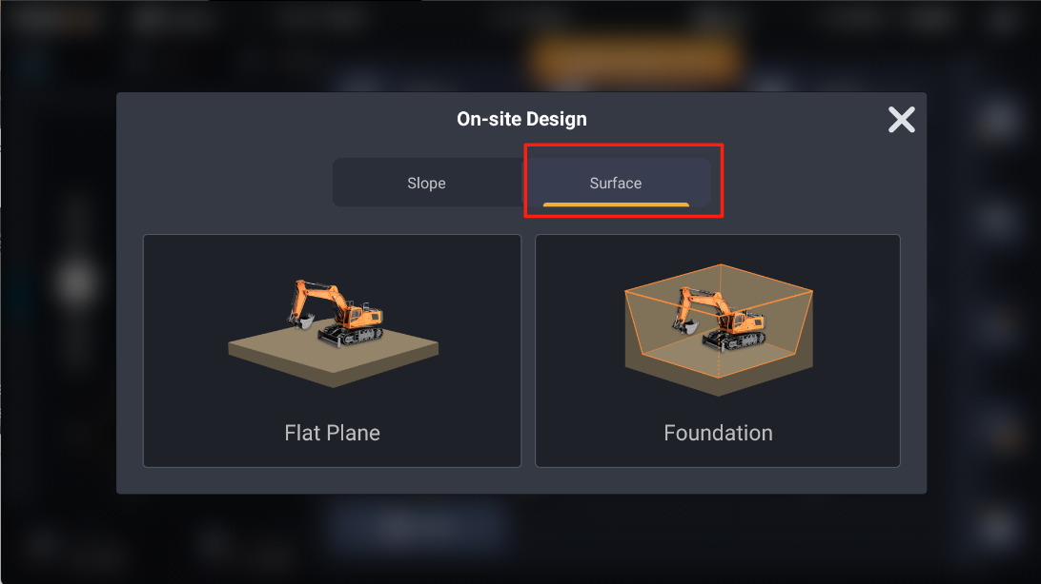

A:Flat Plane

Same as previous operation

B:Foundation

1. Select a point in three ways (Graph Selection, List Selection, Collect)

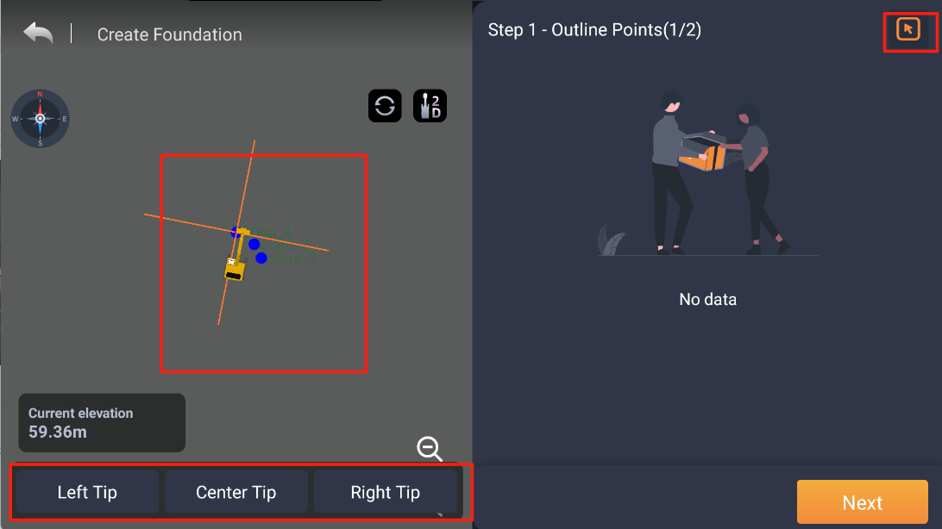

Note:

The collection point will generate a temporary point that will disappear after exiting the foundation pit creation, and the temporary point created in this way can also be clicked

The selected/collected points are added to the list of points on the right, and the left view is centered to the selected point after clicking, and it can be deleted

When there are 3 or more points, the polyline will be automatically closed, and you can click Next

1. Modify the parameters

The three values of Slope, Slope Depth, and Slope Length are linkage parameters:

When you modify Slope, the Depth remains the same and the Length changes. When you change the Depth or Length, the Slope changes.

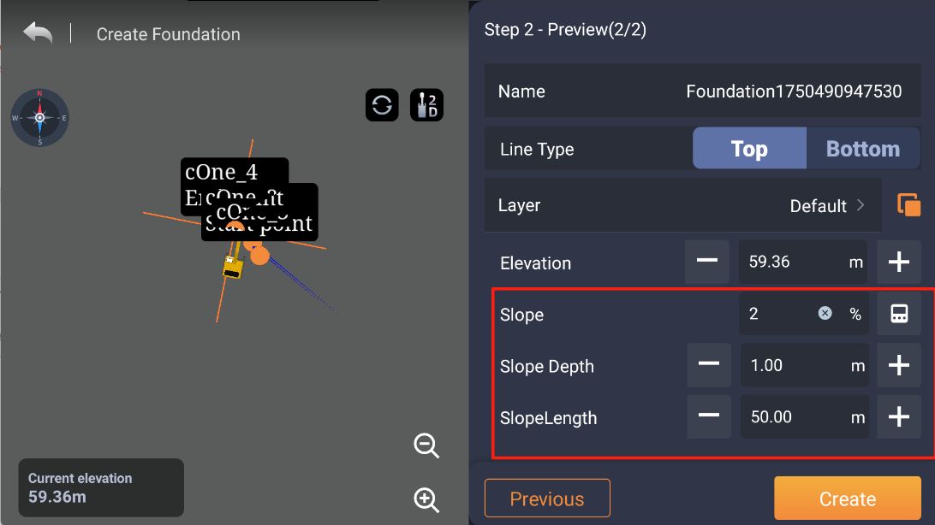

Note:

* Elevation defaults to the elevation of the first point in the point list; The Work Area defaults to 1m(Choose bottom as line type), the Depth,Length defaults to 1m, and the Slope defaults to 100%.
* Click the previous step and then click the next step to come back, and the parameters of the interface will not be lost
* After entering the second step, the left side renders a foundation pit according to the current parameters, including the outer line and the bottom line
* You can create a side wall with a 0Length and the Slope shows 0.0%

1. In the reference information configuration bar, add the left bucket tip north east height, the right bucket tip north east height, and the bucket middle north east height,long-time press on bottom information

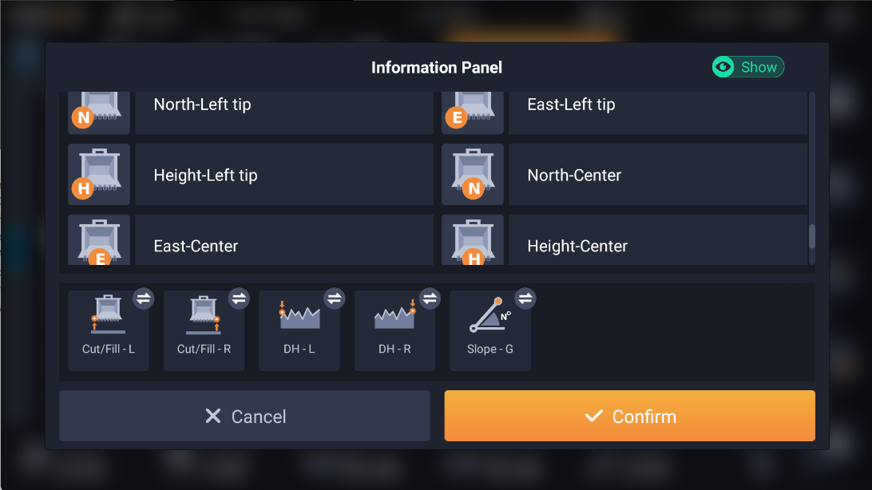

1. Added a follow mode function for the 3D view/top view

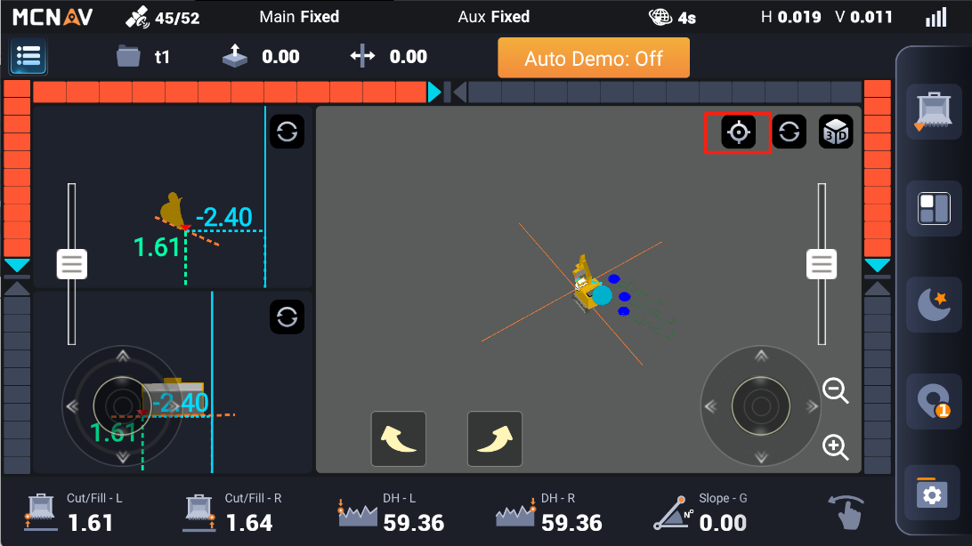

:Free mode(Cancel follow)

:Follow mode

Note:

* Available only on Top view
* Follow mode: The view will lock the guide point, and the customer can adjust the zoom freely. After the view is moved by the customer, wait 5 seconds before the focus returns to the guide point
* Free mode: No restriction on zoom and position adjustment, no automatic centering

1. Manually select the import catalog

Add manual selection of USB flash drive/internal storage to the import interface. When the USB flash drive is inserted, it will automatically switch to the USB flash drive directory when the import interface is entered, and the default internal storage directory will be when the USB flash drive is not inserted

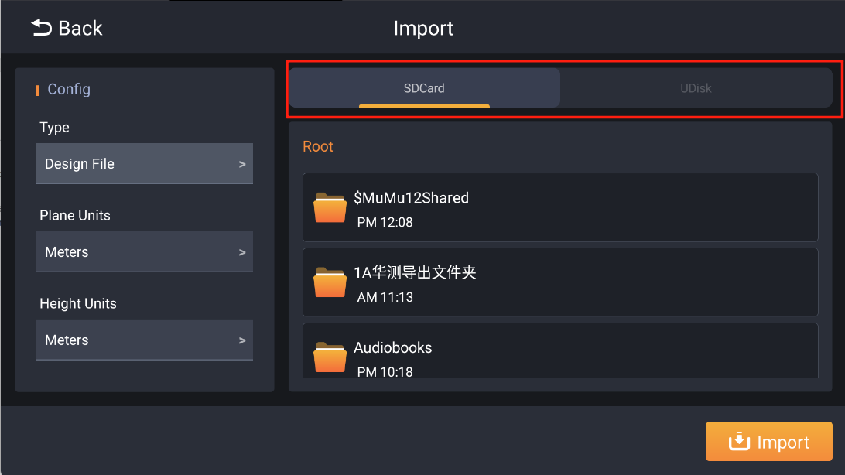

Note:

* This feature is not compatible with file manager[Es file explorer],You need to manually uninstall the previous file manager and install the latest file manager [Cx file manager]

**Link to get it :https://www.jianguoyun.com/p/DaNSV7QQ_ZCUDRi__fwFIAA**

* We will equip this file manager by default in the next firmware version of the tablet
* The default units for importing design data follow the project

1. The bucket quick switching interface has been changed, and the tilter can turn off the rotation data

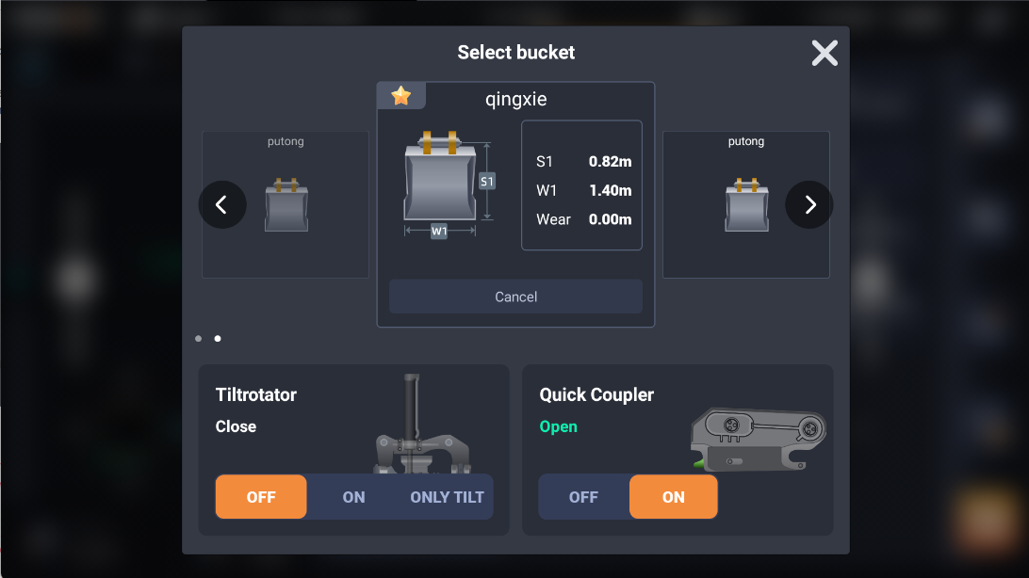

1. Project time format configuration

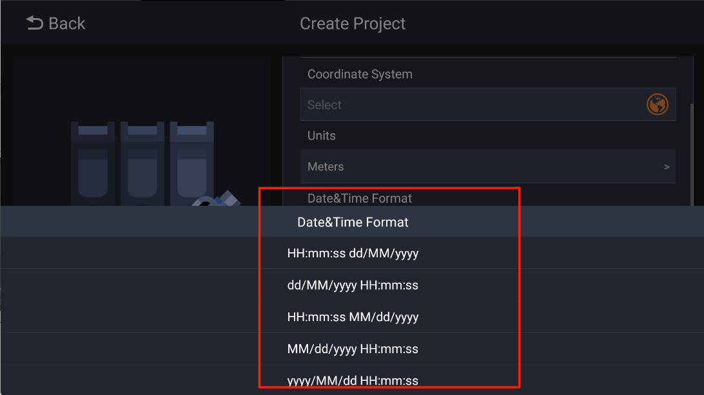

Points exporting time column will follow the project configuration

1. The cloud account function is added, and the terminal can be reversely bound to the surveyor account of the cloud platform

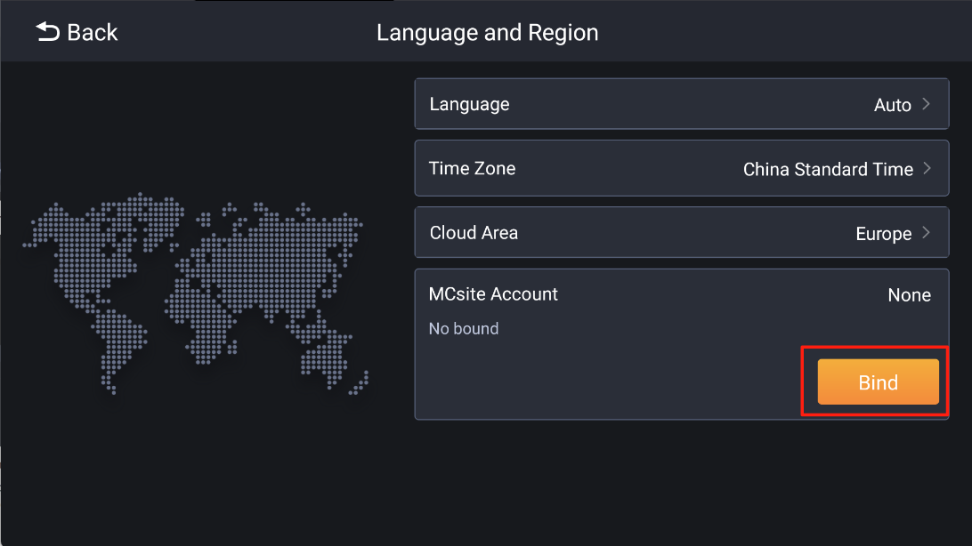

1. Upload the data to the cloud

Click [Menu]-[Projects]-[More]-[Link to]

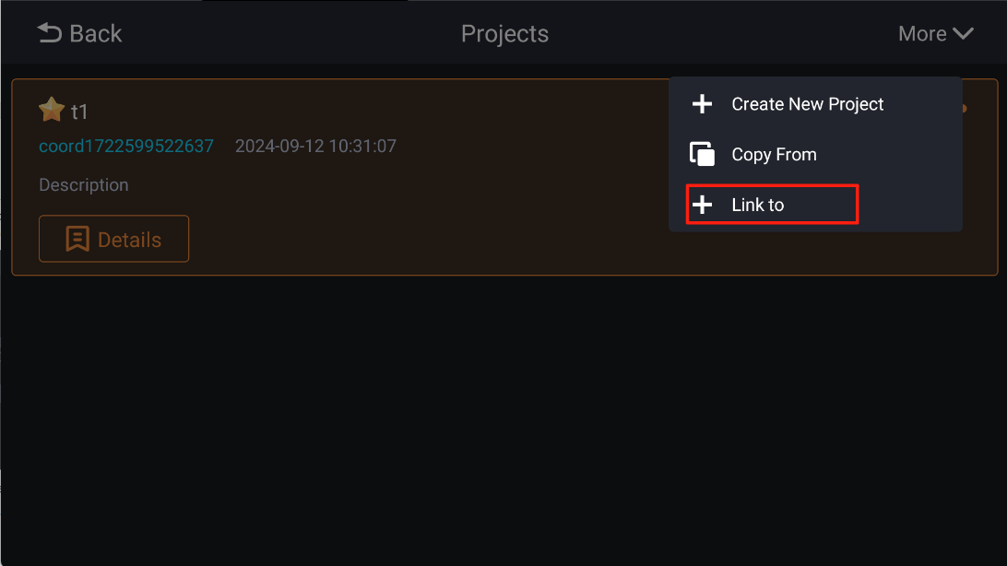

Note:

* A project can be linked to multiple cloud projects
* When the cloud project data of the cloud platform is changed, click Check for Update in the terminal to update the updated file of the cloud project to the terminal

# Fixed issues

1. Change the tilt bucket in the quick drawer, the tilt sensor does not work
2. The CORS password cannot be entered completely
3. The problem of pixel blurring of the excavator model
4. When calibrating [ Antenna correction] step with M1,M2,not available to use center bucket tip
5. Turn on the line spacing guidance, and the main page is stuck in the amount of excavation
6. The Australian TX73 fails to pass after calibration using the local coordinate system
7. After importing design data, it is not possible to select lines for guidance
8. Software is stuck after XML design data is imported
9. After importing the XML file, all the points are incorrectly grouped into a single surface
10. The benchmark base grid in Netherlands was unsuccessfully
11. Fix the issue of abnormal design data sent from the cloud, application exceptions after terminal synchronization, and crashes after software restart.

# Precautions

1. The sliced view software crashes and exits, which can be resolved by restarting the system
2. Switch 2D/3D, the software has a chance to crash and exit, which can be solved by restarting the system
3. Click the hidden button on the main control panel, and the software crashes and exits, which can be solved by restarting the system
4. Probabilistic crashes in imported design data can be resolved by restarting the system